30.75: a) Using Kirchhoff’s Rules: 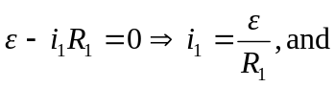
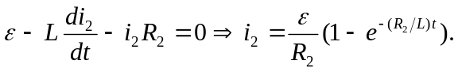
b) After a long time, 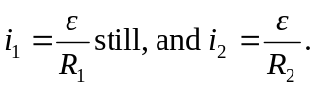
c) After the switch is opened, 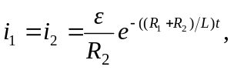 and the current drops off.
d) A 40-W light bulb implies 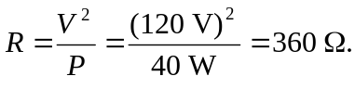If the switch is opened, and the current is to fall from 0.600A to 0.150 A in 0.0800 s, then:
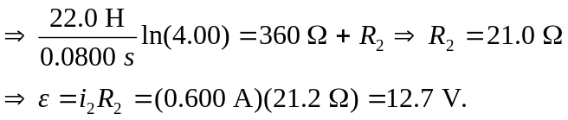
e) Before the switch is opened, 